GKG Blues Cats
Technical Requirements and sound

The band arrive without FOH and monitor engineers!

Promoter should provide a qualified sound engineers and technicians who knows the venue and system.

The sound system used at the performance should meet conditions that makes the artists performance audible to the audience with the highest possibily of sound quality. All systems should meet professional stage standards.

Monitors:

Aux 1 – Lead vocal/guitar - 2 wedges (insert EQ).
Aux 2 – Bass/back vocal - 2 wedges (insert EQ).
Aux 3 – Drums - 1 wedge (insert EQ).

Back line:

Electric guitar: Reserved guit. amp.- Fender Twin Reverb or
similar tube amp.
Acoustic guitar: 2 DI Box.

Bass guitar: Bass amp.- Ampeg (SVT3, SVT2) or similar
Gallien-Krueger; Hartke.
Speaker cabinet- 8x10”or 6x10” or 4x10”.

Drum set: Any available (Premier, Yamaha…)
1 Bass drum.
1 Rack tom.
1 Floor tom.
1 Snare drum.
Hardware: Bass drum pedal.
Snare drum stend.
HH stand.
2 Cymbal stends (ride, crash).
1 Drum seat.
Cymbals: HH, Crash, Ride (Zildjian, Paiste…)

The drumer is left-handed!

All the drumheads must be in good condition.
Please provide carpet under drum set.

Input list:

1.Kick Shure Beta 52, AKG D112. (insert gate)
2.Snare Shure SM 57. (insert compr/gate)
3.HH Shure SM 81.
4.Tom Shure SM 57. (insert gate)
5.F.Tom Shure SM 57. (insert gate)
6.OH Shure SM 81.
7.OH Shure SM 81.
8.Bass DI/Line (insert compr)
9.Electric guit Shure SM 57 (stand short boom)
10.Acoustic guit Left DI.
11.Acoustic guit Right DI.
12.Voc Shure SM 58. (insert compr)
13.Back voc Shure SM 58. (insert compr)
14/15.Rev return

Stage plot:
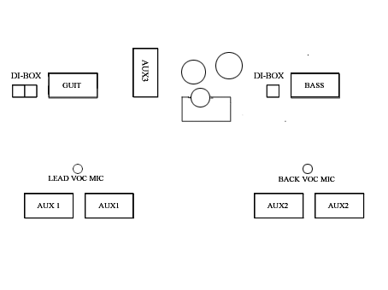
www.gkgbluescats.com

